Most conservative:

From **UK Standard Industrial Classification of Economic Activities 2007** – SIC(2007), explanatory notes:

72.11 Research and experimental development on biotechnology

21.20 manufacture of biotech pharmaceuticals

UK Government website <https://www.gov.uk/government/statistics/bioscience-and-health-technology-sector-statistics-2020/bioscience-and-health-technology-sector-statistics-2020-user-guide#alignment-with-standard-industry-classification-sic-codes>

Standard Industry Classification (SIC) codes are used to classify businesses by industry in administrative statistics. This was last updated in 2008[footnote 7]. This classification system has categories for businesses whose primary activity is the manufacture of pharmaceuticals, manufacture of types of medical equipment, and those whose primary activity is biotechnology R&D.

The SIC system, however, does not allow identification of the full range of life sciences businesses. A bespoke industry segmentation based on this wider range, specifically to be used in the database, was defined with the assistance of the data partners and is summarised in the Segmentation section of this User Guide.

We have analysed the SIC codes of the businesses within the database and only 25% of businesses fall into the standard SIC codes used to identify the life sciences industry. The remaining businesses fall into another 250 SIC codes.

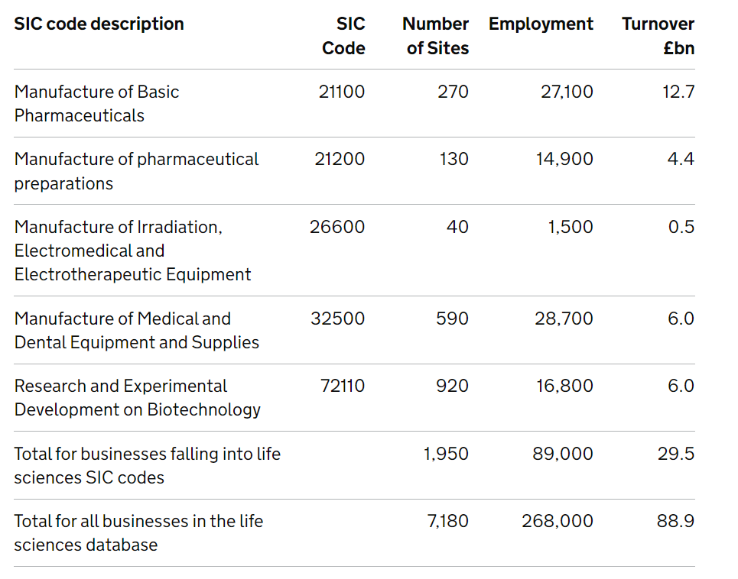

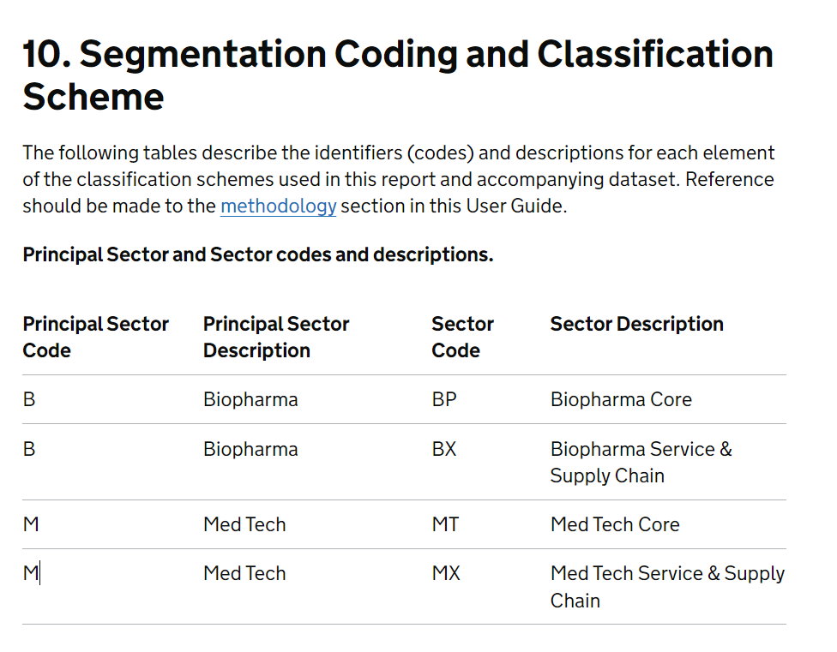

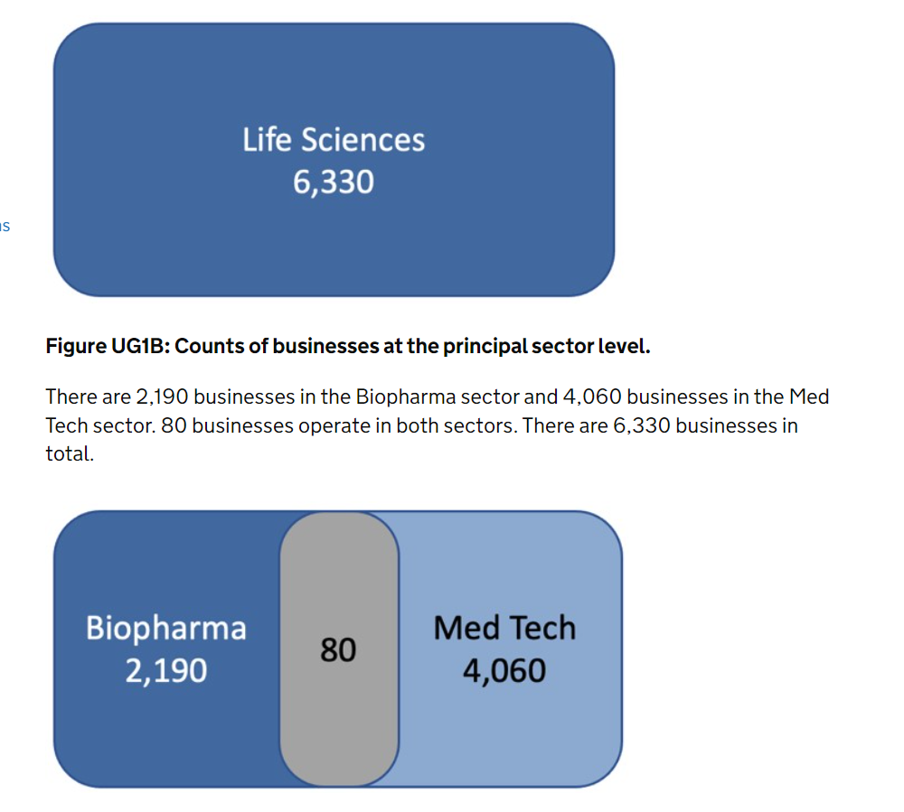

From Biotechnology in Denmark: A Preliminary Report by Carter Bloch, The Danish Centre for Studies in Research and Research Policy, University of Aarhus

**Firms were identified as being biotech firms based on information from their web sites** and the above-mentioned sources. This determination was made based on the OECD’s definition of biotechnology as “the application of science and technology to living organisms as well as parts, products and models thereof, to alter living or non-living materials for the production of knowledge, goods and services”, and the list therein of included biotechnologies.

Firms with biotechnology activities are classified into three groups:  
I. Core biotechnology firms Firms that are active in R&D in biotechnology and for which biotech constitutes the firm’s central activity.  
II. Firms active in biotechnology Firms that have significant activities in biotechnology, but for which biotechnology may not constitute the central part of their activities.  
III. Biotech users Firms that are less active in biotech R&D, and are mainly involved in the use of biotechnology in the production of other products. Since Denmark has not yet conducted a biotechnology survey, our knowledge of users of biotechnology is limited.

At the end of 2003, there were 181 core biotechnology firms (group I) in Denmark, with a total of 4766 employees3 . In addition, we identified an additional 86 firms with significant activities in biotechnology (group II).

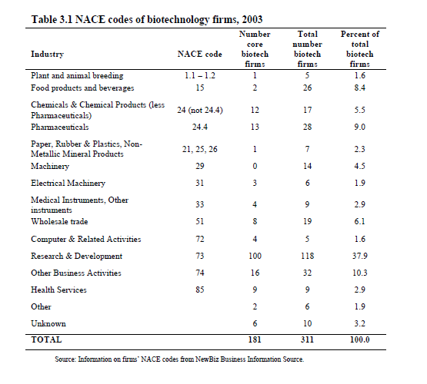

NACE: 1.1, 1.2, 15, 21, 24, 25, 26, 29, 31, 33, 51, 72, 73, 74, 85

# Old SIC codes, but interesting for metodology

## From : The nanotech versus the biotech revolution: Sources of productivity in incumbent firm research (old codes, from 1980 to 2000)

Frank T. Rothaermel

* SIC 2834 (pharmaceutical preparations)
* SIC 2800 (chemicals and allied products)
* SIC 2820 plastic materials, synthetic resin/rubber, cellulose (no glass)
* SIC 2821 (plastic materials, synthetic resins and non-vulcan elastomers
* SIC 2060 (sugar and confectionery products);
* SIC 2090 (miscellaneous food preparations and kindred products);
* SIC 2200 (textile mill products);
* SIC 2221 (broadwoven fabric mills, man made fiber and silk);
* SIC 2840 (soap, detergents, cleaning preparations, perfumes, cosmetics);
* 2844 (perfumes, cosmetics and other toilet preparations);
* SIC 2870 (agricultural chemicals);
* SIC 2911 (petroleum refining);
* SIC 5090 (wholesale-miscellaneous durable goods)

Incumbent pharmaceutical firms are the firms that were in existence prior to the emergence of biotechnology.

To draw this sample, we relied on numerous sources documenting the global pharmaceutical biotechnology industry (in alphabetical order): BioScan (annual volumes), Burrill & Company Life Sciences Annual Industry Reports, Compustat, Datastream (Thomson Financial), Ernst & Young's Annual Biotech Industry Reports, FIS Mergent, Osiris, Recombinant Capital, Scrip's Yearbooks on the Global Pharmaceutical Industry, SIC listings, among others. We identified all pharmaceutical companies active as of 1980 and followed them through 2003.

We used the following sources to construct the two longitudinal panel datasets: We obtained firm's R&D expenditures (as well as all other financial data) from Compustat and Datastream. Alliance data for the biotechnology industry were drawn from BioScan and Recombinant Capital. BioScan, which is published by American Health Consultants, is a publicly available industry directory that provides data about the worldwide biotechnology industry. The sources for the BioScan data are mainly company questionnaires, but also include news releases, annual reports, SEC and FDA filings, journals, and investment reports, among others. Recombinant Capital is a life science industry consulting firm that provides detailed descriptions of alliances in the pharmaceutical biotechnology industry. The sources of Recombinant Capital alliance data are comprised of SEC and FDA filings, press releases, industry conferences, and industry contacts, among others. BioScan and Recombinant Capital appear to be the two most comprehensive publicly available data sources documenting alliance activity in the biotechnology industry. Both sources are fairly consistent and accurate in reporting alliances (their inter-source reliability was greater than 0.90). Alliance data for the nanotech sample was drawn from the SDC Platinum database, published by Thomson Financial. We also used this source to track R&D acquisitions by both the incumbent firms in the biotech and nanotech samples.

The distribution of SIC codes is as follows: SIC 2834 (pharmaceutical preparations) 51 firms; SIC 2800 (chemicals and allied products) 6 firms; SIC 2820 plastic materials, synthetic resin/rubber, cellulose (no glass) 2 firms; SIC 2821 (plastic materials, synthetic resins and non-vulcan elastomers) 2 firms; and 1 firm each in the following SIC codes: SIC 2060 (sugar and confectionery products); SIC 2090 (miscellaneous food preparations and kindred products); SIC 2200 (textile mill products); SIC 2221 (broadwoven fabric mills, man made fiber and silk); SIC 2840 (soap, detergents, cleaning preparations, perfumes, cosmetics); 2844 (perfumes, cosmetics and other toilet preparations); SIC 2870 (agricultural chemicals); SIC 2911 (petroleum refining); SIC 5090 (wholesale-miscellaneous durable goods); and for 10 firms a primary SIC code was not specified.

From Guo, Lev, and Zhou (2005): SIC codes 283, 8783

# How many?

# 

https://www.ey.com/en_us/life-sciences/beyond-borders#marketoform